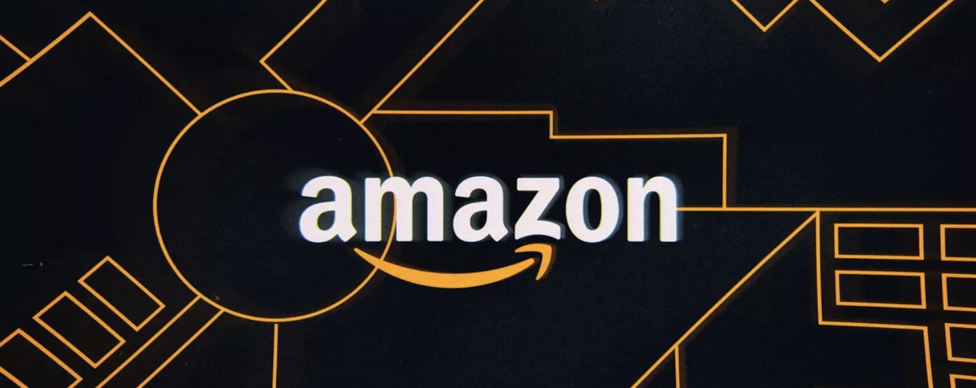

Congrats!

At this point, you should have passed Amazon background, Litmos training, and had a call with me, your District Manager.

Your next step is to have group training call so we can go over more details about how to work Amazon.

On the call, I’ll review the Amazon process and the materials attached (Please review the documents prior to the call.) Also, try to log in to your account. You should have received an email about how to create your password from Amazon. Also, your username is your Apollo company email.

Your training review conference call is scheduled for:

Tues Aug 20 at 5p EST (Eastern Standard Time)

Please look out for an email invite and accept the meeting! You must dial in and use access code to join the call.
Dial-in Number: | (515) 604-9975
Access Code: 518856

Download the Amazon “Selling Services app” prior to the call:

https://play.google.com/store/apps/details?id=com.amazon.technician.android

https://itunes.apple.com/us/app/selling-services-on-amazon/id988788863?mt=8

If you have any further questions, feel free to contact me!

Kind Regards,

Your District Manager

