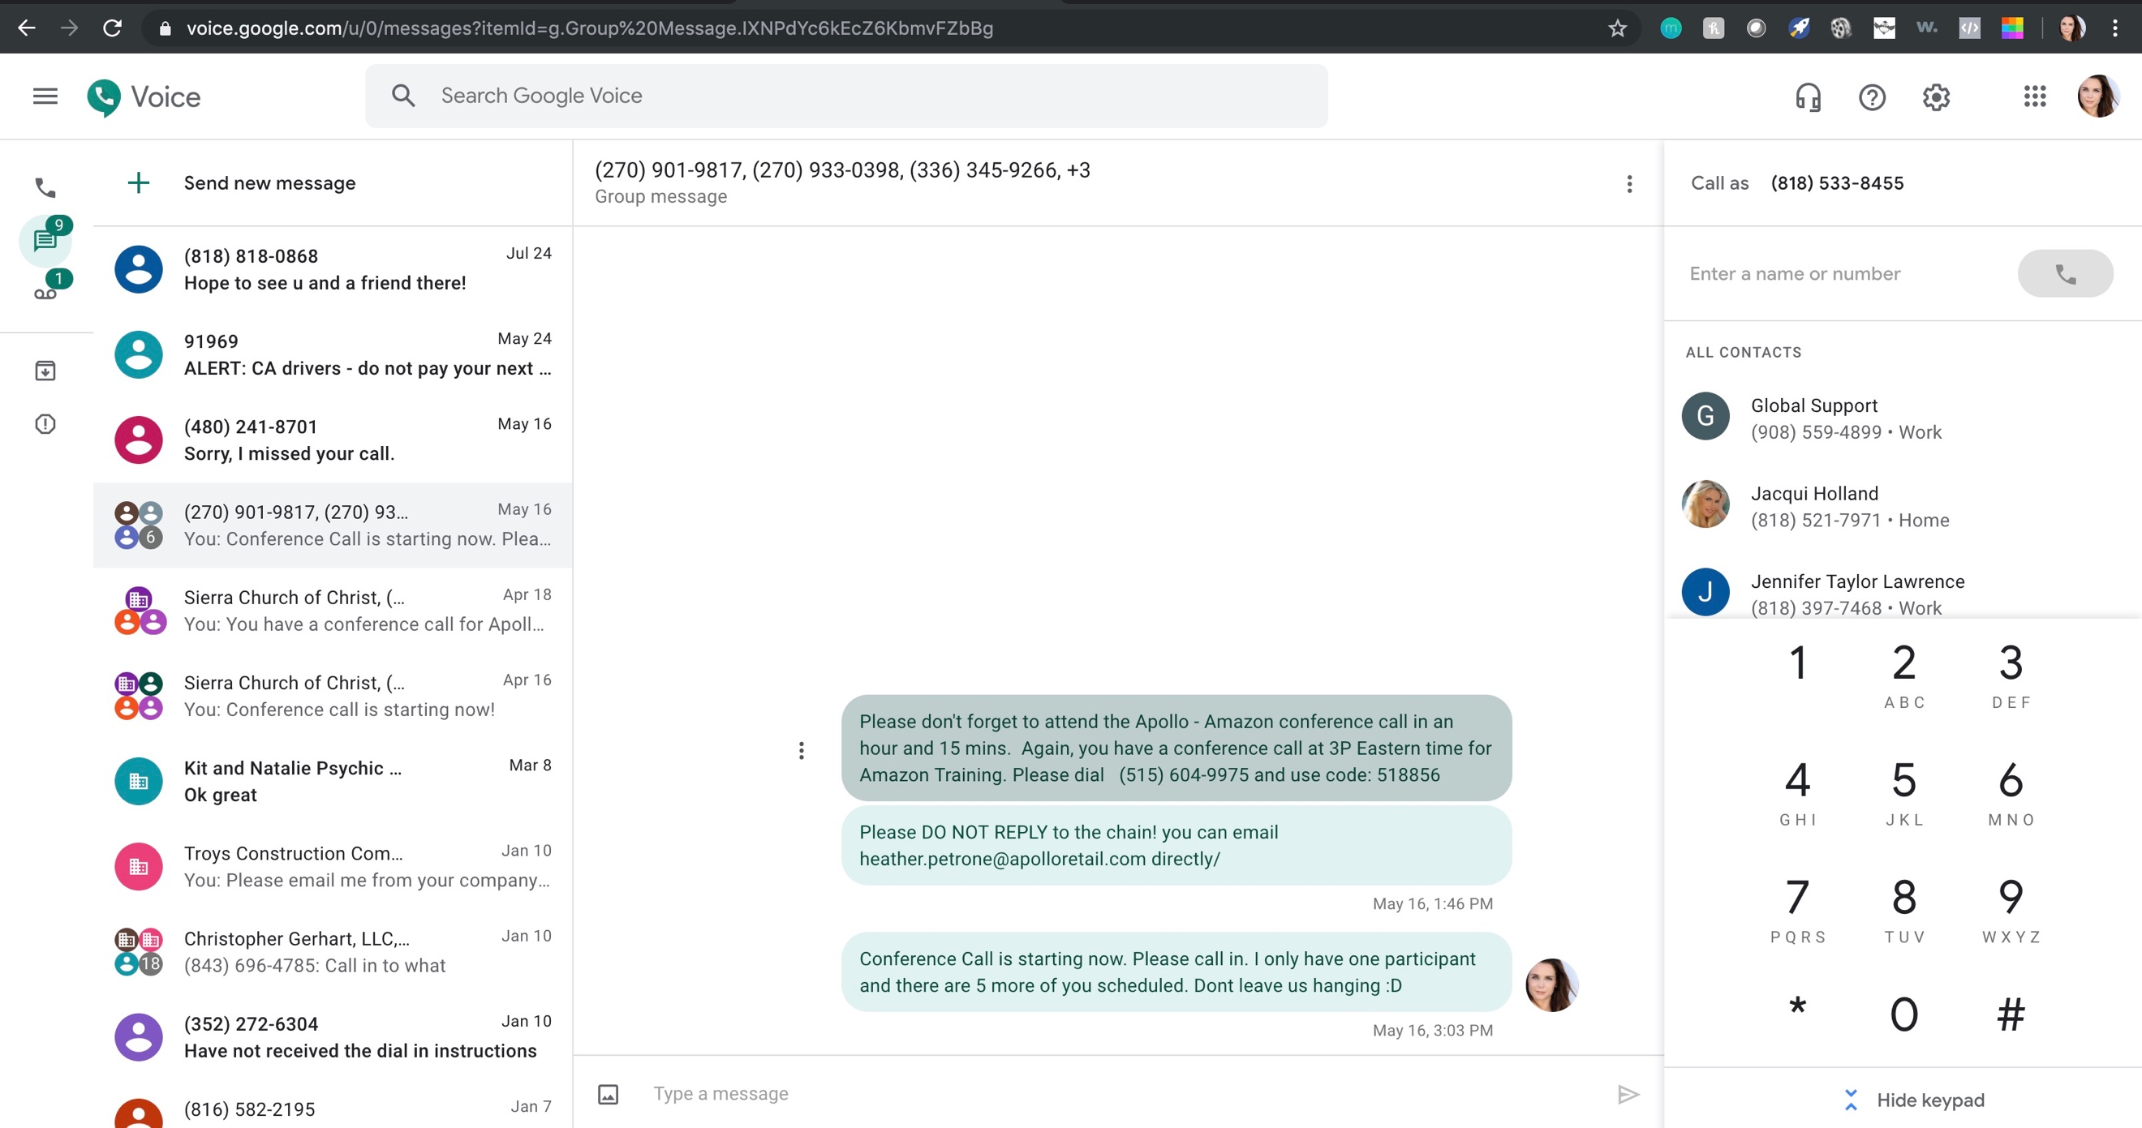

Create your own account: https://voice.google.com/

